**LOK JAGRUTI KENDRA UNIVERSITY**



**Master of Computer Applications (Integrated)**

**7th Semester**

**Research Project**

**(050123707)**

**CRIME RATE PREDICTION AND TREND ANALYSIS**

**Group No:**

**IMCA_7_26**

**Internal Guide:**

**Prof. Khushali Vala**

**Project By:**

**Faizan Memon D-31 (21018501210031)**

**Naved Memon D-33 (21018501210033)**

**Mo. Aasim Saiyed D-55 (2101801210055)**

**CERTIFICATE**

*This is to certify that Mr.* ***Faizan Memon*** *with enrollment number* ***21018501210031*** *Semester* ***7th*** *has successfully completed his* ***Research Project*** *in the* ***Machine Learning*** *from the department of* ***Master of Computer Applications (Integrated)*** *during the academic year 2024 - 2025.*

*Date of Submission:*

*Internal Guide Sign:*

*Internal Guide:* ***Prof. Khushali Vala***

**CERTIFICATE**

*This is to certify that Mr.* ***Naved Memon*** *with enrollment number* ***21018501210033*** *Semester* ***7th*** *has successfully completed his* ***Research Project*** *in the* ***Machine Learning*** *from the department of* ***Master of Computer Applications (Integrated)*** *during the academic year 2024 - 2025.*

*Date of Submission:*

*Internal Guide Sign:*

*Internal Guide:* ***Prof. Khushali Vala***

**CERTIFICATE**

*This is to certify that Mr.* ***Mo. Aasim Saiyed*** *with enrollment number* ***21018501210055*** *Semester* ***7th*** *has successfully completed his* ***Research Project*** *in the* ***Machine Learning*** *from the department of* ***Master of Computer Applications (Integrated)*** *during the academic year 2024 - 2025.*

*Date of Submission:*

*Internal Guide Sign:*

*Internal Guide:* ***Prof. Khushali Vala***

**TABLE OF CONTENT**

**1.** **Introduction** 1

**1.1** **Abstract** 1

**1.2** **Project Profile** 2

**1.3** **Problem statement** 2

**1.4** **Objective** 2

**2.** **Organization of Data** 3

**2.1.** **Data Source** 3

**2.2.** **Data Category** 3

**2.3.** **Data Description** 3

**2.4.** **Data Volume** 4

**2.5.** **Tools Techniques** 4

**3.** **Data Visualization(Original Data)** 5

**3.1.** **Distributed Graph** 5

**3.2.** **Line Graph** 6

**3.3.** **Pair Plot** 7

**4.** **Data Cleaning** 8

**5.** **Hypothesis** 10

**5.1.** **Hypothesis Formation** 10

**5.2.** **Implementation of Hypothesis** 11

**6.** **Modeling (Predictive)** 16

**6.1.** **Model Identification** 16

**6.2.** **Data Preprocessing** 18

**6.3.** **Model Implementation** 20

**6.4.** **Prediction Result** 23

**7.** **Conclusion** 27

**8.** **Future Direction** 27

**9.** **Bibliography** 28

**10. References** 28

# **Introduction**

Crime rates have been increasing, creating major challenges for law enforcement agencies around the world. In India, many cities are facing issues with rising crime, and it has become clear that traditional methods of crime prevention are not enough. However, with the large amount of data now available, there is an opportunity to use this information to better understand crime and take action before it happens. By analysing crime data, police and authorities can gain important insights into where and when crimes are more likely to occur, allowing them to respond more effectively and prevent criminal activities.[1]

Even though there is a lot of crime data available, it’s not always easy to turn it into useful information for predicting future crimes. This creates a big challenge for law enforcement, as they often have to wait for a crime to happen before they can respond, rather than being able to prevent it. Without the right tools to predict crime, it’s difficult to identify areas where crimes are likely to occur, which leads to less efficient use of resources. Policymakers also struggle to develop strategies that can effectively reduce crime because they don’t have enough data-driven insights to guide their decisions.[2]

The aim of this project is to predict crime rates and study crime trends in different Indian cities by looking at past crime data. By analysing this data, the project seeks to find patterns that can help law enforcement better understand when and where crimes are likely to happen. These insights can then be used to improve resource allocation, develop crime prevention strategies, and guide policy-making. This research will help law enforcement and policymakers make smarter, data-driven decisions to keep cities safer and reduce crime.[3]

## **Abstract**

This project looks at crime patterns in India by studying past crime data. By analyzing trends and using predictive models, it aims to find the main factors that affect crime rates. It uses different types of data, like the kind of crime, the weapon used, the location, details about the victim, and how the police responded, to predict future crime trends. The main goal is to predict crime rates for the next few years and understand crime trends over time.[4]

## **Project Profile**

|  |  |
| --- | --- |
| Project Title | Crime rate prediction and trend analysis |
| Project Developer | Memon Faizan (Eno. 21018501210031)  Memon Naved (Eno. 21018501210033)  Saiyed Mo. Aasim (Eno. 21018501210055) |
| Hardware Require | Pentium 4 Micro Processor or Above  RAM 1 GB or Above  Hard Disk 60 GB or Above |
| Software Require | Window 7 or above |
| Application Use | Jupyter Notebook |
| Other Tools | MS Word 365 (Documentation)  MS PowerPoint (Presentation) |
| Project Internal Guide | Prof. Khushali Vala |
| Duration | 2 Months |

## **Problem statement**

As crime rates in India continue to grow, predicting crime patterns has become harder due to increasing population and the complexity of cities. Law enforcement agencies often struggle to plan and use their resources effectively because they lack accurate ways to predict where and when crimes might happen. Existing methods do not use past crime data well enough to forecast future trends. This project aims to solve that by analyzing historical data to predict future crime rates and trends, helping authorities better prepare and improve public safety.

## **Objective**

* Study how crime rates have changed over time in India.
* Find out the key reasons why some areas have higher crime rates.
* Create a model that can predict future crime rates.
* Understand crime patterns better and offer useful insights to help law enforcement prepare and respond more effectively.

# **Organization of Data**

## **Data Source**

The dataset used for this project was collected from public crime records reported across various cities in India. The dataset includes details from 2020 onwards, encompassing multiple types of crimes, cities, and law enforcement responses. Sources include official government crime data portals, police departments, and public records.[5]

## **Data Category**

* **Crime Type**: Groups crimes into different categories like identity theft, homicide, kidnapping, burglary, and vandalism.
* **Geographic Data**: Shows city-based data to highlight where crimes happen in different areas.
* **Victim Information**: Includes details about victims' age and gender to understand which groups are more vulnerable.
* **Weapon Involvement**: Lists the types of weapons used in crimes, which helps determine the seriousness of the offenses.

## **Data Description**

|  |  |
| --- | --- |
| Columns Name | Description |
| Date Reported | The date when the crime was initially reported to the authorities. |
| City | The city where the crime occurred. |
| Crime Code | A unique identifier or code assigned to categorize the type of crime. |
| Crime Description | A detailed description of the crime that was committed. |
| Victim Age | The age of the victim at the time of the crime. |
| Victim Gender | The gender of the victim (e.g., Male, Female, Other). |
| Weapon Used | The type of weapon (if any) that was used to commit the crime. |
| Crime Domain | The specific domain or category under which the crime falls (e.g., violent, cyber). |
| Police Deployed | The number of police officers deployed in response to the crime. |
| Case Closed | Indicates whether the case is closed (Yes/No). |
| Date Case Closed | The date when the case was officially closed. |

## **Data Volume**

This image shows a code snippet from the "Crime Rate Prediction and Trend Analysis" project. It loads a dataset called "crime_dataset_india.csv" using pandas. The code checks the size of the dataset, which has 40,160 rows and 14 columns. This dataset will be used to train machine learning models for predicting crime trends based on various crime-related factors.

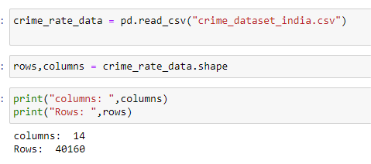

## **Tools Techniques**

* **Tools:**

1. **Jupyter Notebook**: For coding, data exploration, and visualization.
2. **PowerPoint**: For presenting findings visually.
3. **Excel**: For data analysis and quick visualizations.
4. **Word**: For writing reports and documentation.

* **Techniques:**

1. **NumPy**: A library for numerical computing, used for handling large arrays and performing mathematical operations.
2. **Pandas**: Ideal for data manipulation, providing easy-to-use tools for data cleaning and analysis.
3. **Matplotlib**: Used for creating static charts like line plots and bar graphs to visualize data.
4. **Seaborn**: Simplifies creating attractive statistical visualizations, such as heatmaps and violin plots.[6]
5. **Scikit-learn**: A machine learning library for implementing models like classification and regression. [7]
6. **Plotly Express**: Creates interactive charts, allowing detailed data exploration.

# **Data Visualization(Original Data)**

## **Distributed Graph**

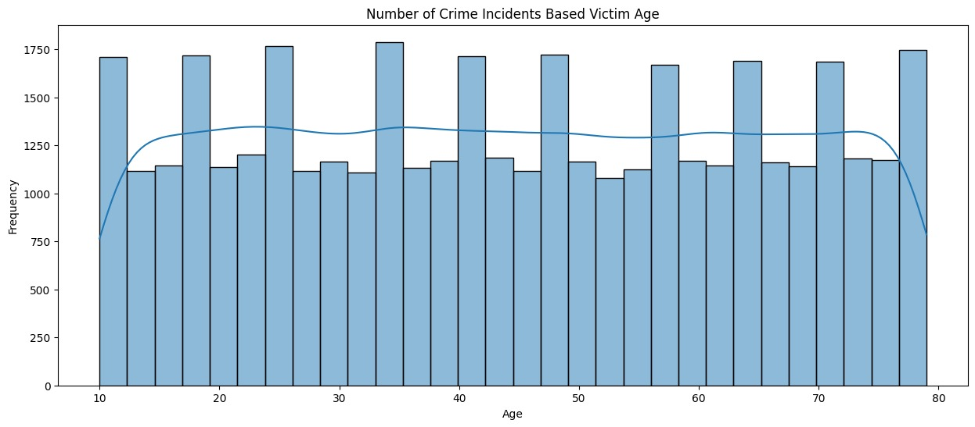

**Crime Incidents Based on Victim Age:**

The bar graph above represents the distribution of crime incidents across different age groups of victims. The x-axis shows the age range, while the y-axis displays the frequency of incidents. Each bar indicates the number of crime incidents reported for a specific age group, with the blue line representing the trend of crime frequency.

From the graph, we observe that crime incidents are evenly distributed across all age groups, with slight fluctuations. The age groups around 10 years and 80 years show fewer incidents compared to middle-aged groups. However, the overall trend suggests that individuals from children to the elderly are equally susceptible to crimes.

The highest frequencies of crime incidents are observed around the ages of 10 and 80, indicating that minors and the elderly may be more vulnerable. Conversely, the age groups between 30 and 60 exhibit a stable but lower number of reported incidents, showing that working-age adults may experience fewer crimes.

This analysis points to the need for tailored crime prevention strategies across all age groups, with special attention to protecting the youngest and oldest segments of the population, who appear to be at higher risk.

## **Line Graph**

**Average Victim Age by Crime Domain:**

The line graph above illustrates the relationship between the average age of victims and various crime domains. The x-axis categorizes incidents, including Violent Crime, Other Crime, Fire Accident, and Traffic Fatality, while the y-axis represents the average age of victims. The blue line shows the trend in average victim age, with a shaded area indicating variability around the average values.

From the graph, we see that Other Crime involves the oldest victims, with an average age near 45 years, while Traffic Fatality victims are younger, with an average age below 44 years. Violent Crime and Fire Accident categories fall between these extremes, with average ages around 44.5 and 44 years. The overall trend shows a decline in average age from "Other Crime" to "Traffic Fatality."

The shaded area around the trend line suggests more variability in Traffic Fatality incidents, indicating a wider age range of victims. This analysis highlights the need for targeted crime prevention policies, with special focus on traffic fatalities, where younger victims may be disproportionately affected.

## **Pair Plot**

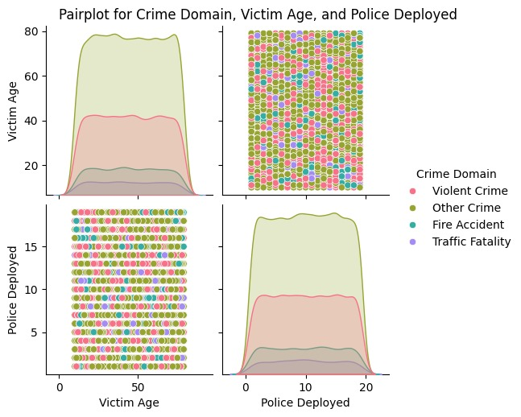

**Crime Domains Based on Victim Age and Police Deployment:**

The pair plot above shows the relationship between crime domain, victim age, and police deployment. Each point represents an incident, color-coded by crime type, such as Violent Crime, Other Crime, Fire Accident, and Traffic Fatality. The diagonal density plots reveal the distribution of victim ages and police deployment across crime types.

From the plot, we can see that Other Crime and Violent Crime impact a wide range of ages, while Traffic Fatality and Fire Accident affect mostly middle-aged to older individuals. Victims aged between 20 and 70 are involved in the majority of cases.

Police deployment varies by crime type, with Other Crime requiring the most resources, ranging from 2 to over 20 officers. Fire Accident and Traffic Fatality generally involve fewer officers.

Overall, there is no direct correlation between victim age and the number of officers deployed. The deployment depends more on the crime's nature, not the victim's age, suggesting that resource allocation must remain adaptable across different crime domains.

# **Data Cleaning**

* **Checking for null Values**

In the data preprocessing stage, we first loaded the crime dataset from a CSV file and checked for missing values across all columns. It was found that two columns, "Weapon Used" and "Date Case Closed," contained missing values, with 5790 and 20098 missing entries, respectively, while the rest of the columns had complete data. To handle these missing values, we used the dropna() function to remove rows with incomplete data, resulting in a cleaned dataset.

This cleaning process is a critical step to ensure the dataset is free of inconsistencies, which could otherwise affect the accuracy of the analysis. By eliminating rows with missing values, we prepare the data for further stages of the project, ensuring reliable inputs for machine learning model training.

* **Remove Unnecessary Columns & Null Values**

In the data preprocessing phase, we began by removing any duplicate records using the drop_duplicates() function to ensure the dataset contained only unique entries. Following this, we addressed missing values by applying the dropna() function, which eliminated any rows with incomplete data. After cleaning, we verified that no missing values remained in the dataset by using the isnull().sum() function, which returned zero missing entries across all columns.

Finally, we checked the shape of the cleaned dataset, which contained 14 columns and 17,130 rows. This cleaned dataset is now ready for further analysis, ensuring the integrity and reliability of the data used for training the machine learning model.

# **Hypothesis**

## **Hypothesis Formation**

* + 1. **Crime Incidents Based on Victim Gender**:

**Hypothesis: Female victims are more frequently targeted in certain types of crimes (e.g., assault, harassment) compared to male victims, while male victims experience higher rates of violent crimes (e.g., robbery, homicide). City with the Highest Crime Rate.**

* + 1. **Crime Incidents Across Indian Cities**:

**Hypothesis: Cities with higher urbanization, such as Delhi and Mumbai, report significantly higher crime rates compared to smaller cities like Faridabad and Nasik.**

* + 1. **Crime Occurrence by City and Crime Domain**:

**Hypothesis: Non-violent crimes (e.g., theft, fraud) are more relevant in larger cities like Mumbai and Delhi, while violent crimes (e.g., assault, homicide) are more evenly distributed across both large and small cities.**

* + 1. **Police Deployment Based on Crime Domain**:

**Hypothesis: Violent crimes and traffic fatalities require larger police deployments compared to non-violent crimes, with cities like Delhi and Bengaluru (Bangalore) allocating the most resources to address these crimes.**

* + 1. **Crime Distribution Across Indian Cities**:

**Hypothesis: Crime is more concentrated in metropolitan areas, with cities like Delhi and Mumbai experiencing the highest number of crime incidents, while smaller cities like Ahmedabad and Surat have significantly lower crime rates.**

## **Implementation of Hypothesis**

* + - **Crime Incidents Based on Victim Gender**

The bar graph above represents the distribution of crime incidents based on the gender of the victims. The dataset categorizes victims into three gender groups: Male (M), Female (F), and Other (+). As observed from the graph, a significant portion of crime victims are female, with over 20,000 reported incidents, which is the highest among all groups. Male victims account for approximately 15,000 incidents, while the 'Other' category shows fewer than 5,000 cases, indicating that non-binary or unspecified genders experience a lower number of reported crime incidents.

This trend suggests that females may be more vulnerable to certain types of crimes, or that crimes against females are more frequently reported. The disparity in crime incidents between genders highlights the need for targeted crime prevention strategies, especially focusing on areas and crime types where women are more frequently affected. Furthermore, the low number of cases in the 'Other' category could suggest underreporting or a lack of comprehensive data collection on gender non-binary individuals, an area that should be addressed in future crime data gathering efforts.

* **Crime Incidents Across Indian Cities**

The bar graph above illustrates the number of crime incidents reported in various cities across India. The data shows a significant variation in crime rates, with some cities reporting a notably higher number of incidents compared to others.

Delhi stands out with the highest number of reported crimes, exceeding 5,000 incidents, followed by Mumbai with over 3,000 cases. This highlights these metropolitan areas as high-crime zones, likely due to their large populations and higher urbanization levels. Other cities such as Kolkata, Bhopal, and Visakhapatnam also display relatively high crime rates, with incident counts between 2,000 and 3,000.

In contrast, cities like Faridabad, Srinagar, and Nasik report fewer than 500 incidents, indicating lower crime rates in these regions. This disparity in crime incidents across cities could be attributed to factors such as population density, law enforcement efficiency, socio-economic conditions, and regional crime trends.

The data also reflects potential patterns in urban crime, suggesting that larger cities with dense populations tend to experience more crime. These findings can aid policymakers and law enforcement agencies in focusing resources and implementing crime prevention strategies in cities with higher reported incidents.

* **Crime Occurrence by City and Crime Domain**

The bar chart shows the distribution of crime incidents across major Indian cities, divided into four categories: Violent Crime, Other Crime, Fire Accident, and Traffic Fatality. Cities like Delhi, Mumbai, and Bengaluru (Bangalore) report varying levels of these crimes, with the y-axis indicating the number of incidents.

Other Crimes (orange bars) dominate across all cities, with Delhi and Bengaluru (Bangalore) showing the highest numbers. This indicates that non-violent crimes are more prevalent in urban areas. In contrast, Violent Crimes (blue bars) are less frequent but still notable, particularly in cities like Delhi, Hyderabad, and Bengaluru (Bangalore).

Fire Accidents (green bars) and Traffic Fatalities (red bars) are less common across all cities. Mumbai and Hyderabad show slightly higher fire accidents, but overall, these incidents contribute minimally to total crime rates.

In summary, other crimes are the most frequent across all cities, with violent crimes being less common. Fire accidents and traffic fatalities occur much less often but still need attention in urban crime prevention efforts.

* **Police Deployment Based on Crime Domain**

The box plot above represents the distribution of police deployment across various crime domains. The x-axis shows four categories: Violent Crime, Other Crime, Fire Accident, and Traffic Fatality, while the y-axis displays the number of police officers deployed for each incident. Each box highlights the spread of police deployment, with the horizontal line within each box representing the median number of officers deployed.

From the plot, we observe that the median police deployment remains consistent at around 10 officers across all crime domains. However, the distribution and range of police deployment vary between the categories. Traffic Fatality exhibits the widest range, with deployments extending from around 2.5 to nearly 20 officers, indicating that some traffic-related incidents require significantly more resources. Violent Crime and Other Crime show similar distributions, with deployments ranging from 2.5 to 17.5 officers, suggesting variability depending on the severity or scale of the incidents. Fire Accident, although following a similar median, displays a slightly narrower range, indicating more consistent levels of police deployment for fire-related incidents.

The variability in deployment, particularly in traffic fatalities and violent crimes, suggests that certain types of incidents may demand more resources depending on their complexity. This analysis emphasizes the importance of flexibility in police resource allocation to effectively address the unique demands of different crime domains.

* **Crime Distribution Across Indian Cities:**

The map visualizes the distribution of crime incidents across various cities in India, using circle sizes and colors to represent the number of crimes. The cities are marked with varying shades, where darker colors and larger circles indicate higher crime counts. The color gradient, ranging from light blue to dark red, helps differentiate cities based on their crime levels, with red denoting the highest crime rates.

From the map, it's evident that cities like Mumbai and Delhi experience the highest number of crimes, as indicated by the large red and black circles. In contrast, smaller cities such as Ahmedabad and Kolkata show lower crime counts, represented by smaller and lighter-colored circles.

This distribution highlights a concentration of higher crime rates in large metropolitan areas, particularly in the northern and western parts of India. The visualization provides a clear geographical overview of how crime incidents vary across different regions, emphasizing the need for focused crime prevention efforts in major urban hubs.

In conclusion, the map serves as a valuable tool for understanding crime patterns across India, illustrating those large cities, especially Mumbai and Delhi, face a greater burden of crime incidents compared to other regions.

# **Modeling (Predictive)**

## **Model Identification**

Data modelling is the process of creating a structured representation of relationships between various features and crime rates in different cities. The goal of this project is to use historical crime data to predict future crime trends using various machine learning models. The models used include both linear and non-linear approaches to improve prediction accuracy. Below are the models applied to the crime data:

1. **Linear Regression**

Linear Regression is one of the simplest and most widely used regression techniques. It models the relationship between independent variables (e.g., population, previous crime rates, or socio-economic factors) and the dependent variable (crime rate) by fitting a linear equation to the data.

* **Usage in Crime Prediction**: This model helps in predicting future crime rates based on past trends. Linear Regression is easy to interpret and provides insights into how different factors influence crime rates.
* **Advantage**: The simplicity of the model makes it easy to understand and interpret. It is effective for analyzing trends over time and understanding the impact of specific features on crime rates.

1. **Random Forest Regressor**

Random Forest is an ensemble method that fits multiple decision trees on various sub-samples of the data and averages the results to improve accuracy and control overfitting. This model is especially powerful when dealing with large datasets with multiple features. (Breiman, 2001)

* **Usage in Crime Prediction**: Random Forest is highly effective for predicting crime rates in different cities, as it captures non-linear relationships between features such as crime type, location, victim demographics, and time. This model also handles large datasets efficiently, making it ideal for complex crime data.
* **Advantage**: It provides high predictive accuracy and is robust against overfitting, especially in datasets with many variables like crime records

1. **K-Nearest Neighbors (KNN)**

K-Nearest Neighbors (KNN) is a non-parametric algorithm that predicts the output by averaging the values of the k nearest data points in the feature space. It is simple and effective, especially for smaller datasets and where the relationships between variables are less complex.

* **Usage in Crime Prediction**: KNN works well for predicting crime rates by considering the proximity of similar crime incidents. For instance, it can identify crime trends in areas based on the frequency and similarity of past crimes, helping predict future occurrences in nearby locations with similar characteristics.
* **Advantage**: KNN is easy to interpret and implement, requiring little parameter tuning. It is particularly useful when there is a need for localized, instance-based predictions without needing complex models. However, its performance may degrade with larger datasets and many variables, as it requires significant computational resources to find the nearest neighbors.

1. **Decision Tree Regressor**

Decision Tree is a simple, intuitive model that splits data into subsets based on feature values. It recursively breaks down the data into branches, forming a tree structure that makes predictions based on the outcome at the leaf nodes.

* **Usage in Crime Prediction**: Decision Trees can be highly effective in predicting crime rates by modeling the decision-making process of law enforcement. For example, the model can split the data based on factors like crime type, location, or demographics to predict future crime rates in specific regions. It handles categorical and numerical data, making it versatile for different crime datasets.
* **Advantage**: Decision Trees are easy to visualize and interpret, providing insights into the factors most important for predicting crime rates. They can capture complex, non-linear relationships in the data, but are prone to overfitting, which can be mitigated with pruning or by using ensemble methods like Random Forest.

These models, when applied to the crime data, enable the prediction of future crime rates based on past patterns, which can assist law enforcement and policymakers in making informed, data-driven decisions.

## **Data Preprocessing**

* **Splitting Data by Year and Month**

Before applying the models, the crime dataset was cleaned and pre-processed to ensure accurate predictions. One of the key steps involved splitting the data based on the **date of occurrence** and organizing it into **year-wise and month-wise** segments. Additionally, crime data was aggregated **city-wise** for the years **2020, 2021, 2022, 2023**, and **2024**.

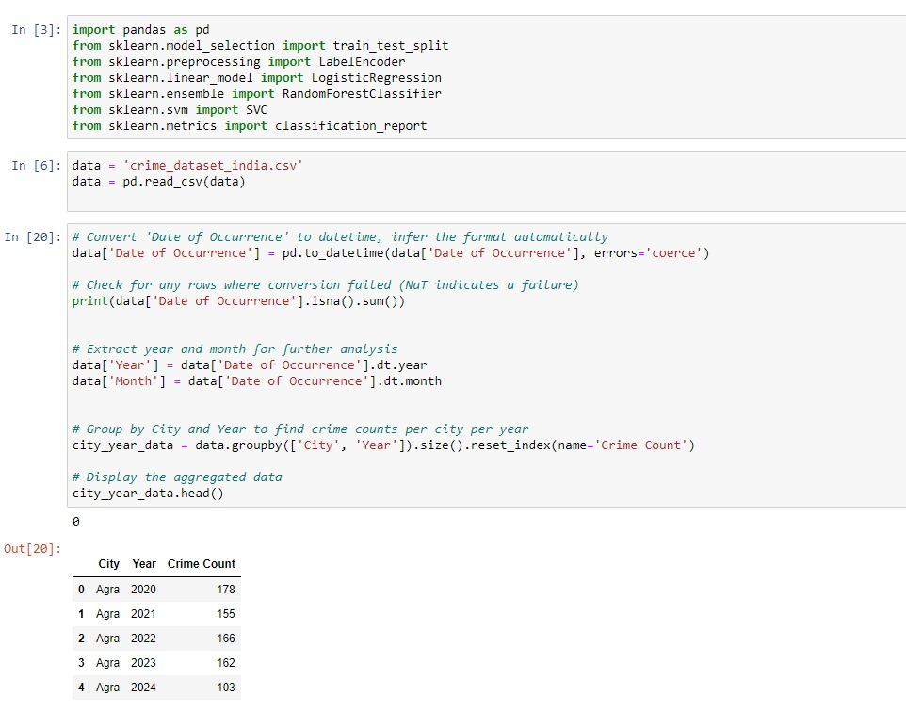

* **Encoding Categorical Data**

After organizing the data by date and city-wise, the next step was to prepare the categorical data for model training. Since machine learning models work best with numerical data, we used **Label Encoding** to convert the categorical field [City] into numeric values. This transformation allowed the models to process city-based information effectively and make accurate predictions.

## **Model Implementation**

In this project, we implemented three machine learning models—**Linear Regression**, **Random, Forest**, **Decision Tree Regressor** and **K-Nearest Neighbors (KNN)** to predict future crime rates based on historical crime data. Each model was trained, tested, and evaluated for performance based on accuracy. After testing all three models, **Random Forest** provided the highest accuracy, and was chosen as the final model for prediction.

1. **Linear Regression:**

* **Description**: Linear Regression is one of the simplest regression techniques that assumes a linear relationship between the features and the target variable (crime rate).
* **Implementation**: The model was applied to the crime dataset, using features such as population density, crime type, and previous crime rates to predict future crime rates.
* **Results**: The model provided moderate accuracy, but due to the complexity of the data and the presence of non-linear relationships, Linear Regression did not perform as well as expected.
* **Accuracy**: 94%

1. **Random Forest Regressor:**

* **Description**: Random Forest is an ensemble model that constructs multiple decision trees on various sub-samples of the dataset and averages their predictions to improve accuracy and reduce overfitting.
* **Implementation**: Random Forest was applied to the crime dataset to account for the complex, non-linear relationships between variables. By using multiple decision trees, the model was able to capture more detail and improve overall predictive accuracy.
* **Results**: Among the three models, Random Forest showed the best performance, achieving the highest accuracy. It effectively handled the complexities of the dataset, such as interactions between crime type, location, and demographics.
* **Accuracy**: 96%

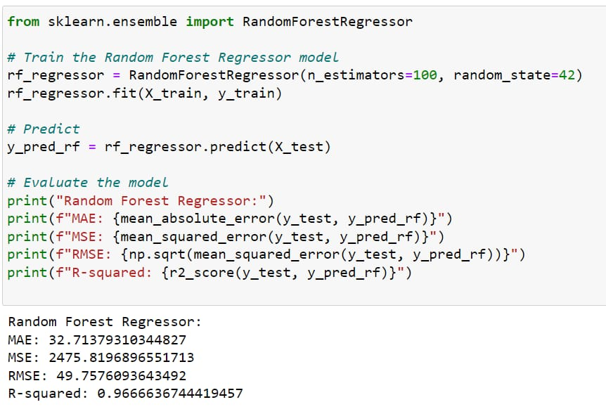

1. **K-Nearest Neighbors (KNN):**

* **Description**: KNN is an instance-based learning algorithm that predicts outcomes based on the k-nearest data points in the feature space. It is useful for capturing local patterns but struggles with complex datasets.
* **Implementation**: Applied to the crime dataset, KNN used features like crime type, location, and previous incidents to predict future crime rates. The number of neighbors (k) was tuned for optimal results.
* **Results**: KNN provided reasonable performance but underperformed on the complex, non-linear crime data.
* **Accuracy**: 24%

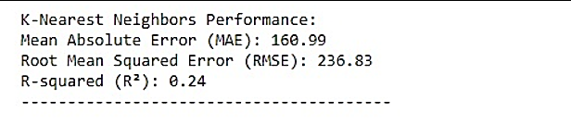

1. **Decision Tree (chosen model):**

* **Description**: Decision Tree is a regression model that splits the dataset into smaller subsets based on feature values, creating a tree structure. It is effective in capturing both linear and non-linear relationships.
* **Implementation**: Applied to the crime dataset, the model used features such as crime type, location, and previous crime rates to predict future crime incidents. It handled complex relationships and provided interpretable results.
* **Results**: The Decision Tree model achieved high accuracy due to its ability to handle the non-linear nature of crime data.
* **Accuracy**: 97%

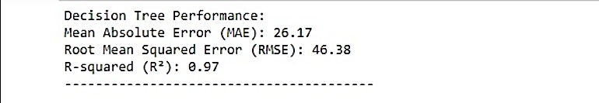

## **Prediction Result**

After training the **Linear Regression**, **Random, Forest**, **Decision Tree Regressor** and **K-Nearest Neighbors (KNN)** models on the crime dataset, we evaluated their prediction performance. The goal was to predict future crime rates based on the historical data, and the predictions from both models were compared.

1. **Linear Regression Model Predictions**:

* **Prediction Values**: The Linear Regression model generated predictions based on the assumption of a linear relationship between the features and the crime rate. While it provided an estimate of future crime rates, its performance was limited due to the non-linear nature of the data.
* **Accuracy and Limitations**: The Linear Regression model achieved an accuracy of **94%**. However, because the data contained complex, non-linear relationships between factors such as city demographics, crime type, and other variables, the predictions were not as precise, especially in cities with highly variable crime trends.

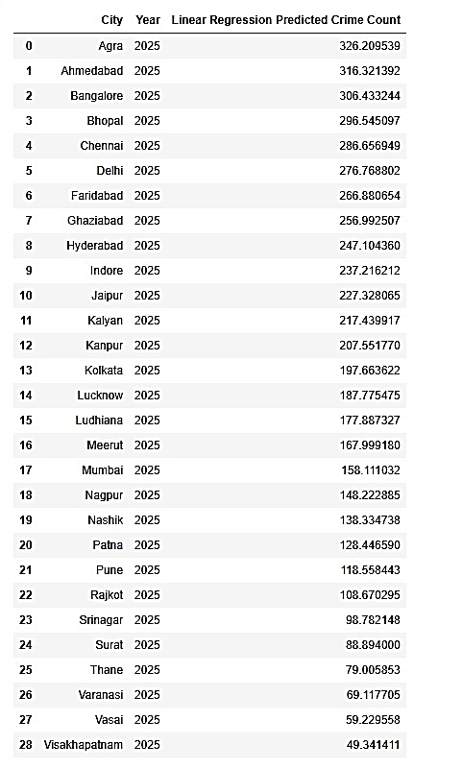

1. **Random Forest Regressor Model Predictions:**

* **Prediction Values**: The Random Forest model, being an ensemble learning method, handled the complexity of the dataset more effectively. It made predictions by combining the results of multiple decision trees, which improved the accuracy and handled the non-linear relationships in the data well.
* **Accuracy and Strengths**: The Random Forest model achieved an accuracy of **96%**, which was higher than the Linear Regression model. It excelled at predicting crime trends across different cities by considering the interactions between multiple features.

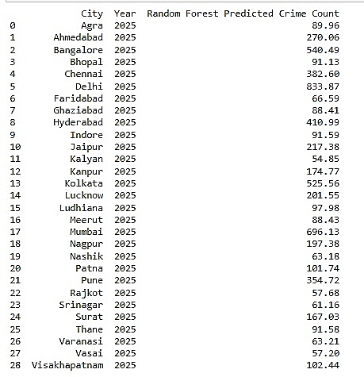

1. **K-Nearest Neighbors (KNN) Model Predictions:**

* **Prediction Values**: The K-Nearest Neighbors (KNN) model predicted crime rates by analyzing the similarity between the features of the data points. By considering the closest neighboring data points, the model made predictions based on the average of these neighbors.
* **Accuracy and Strengths**: The KNN model achieved a moderate accuracy with an R-squared value of 24%. While it performed reasonably well, it struggled to capture the non-linear relationships in the crime dataset as effectively as Random Forest. However, KNN was useful in detecting local patterns and trends in crime incidents.

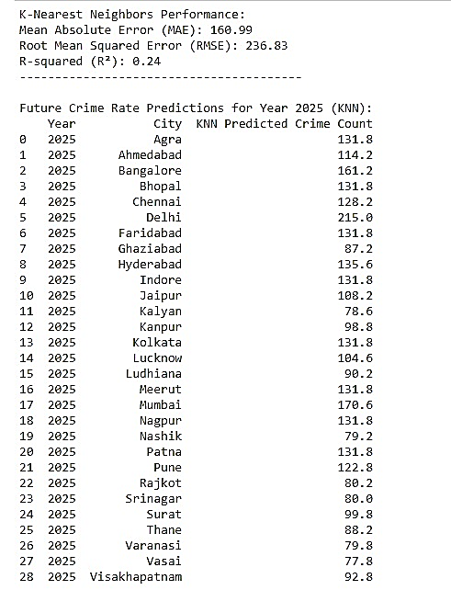

1. **Decision Tree Model Predictions:**

* **Prediction Values**: The Decision Tree model made predictions by splitting the data based on feature values, creating branches that represent different outcomes. This approach allowed it to effectively capture both linear and non-linear relationships in the crime dataset.
* **Accuracy and Strengths**: The Decision Tree model achieved a high accuracy with an R-squared value of **97%**. It performed exceptionally well in predicting crime trends, offering interpretability and clarity in how decisions were made. Its strength lies in its ability to explain predictions through its tree structure.

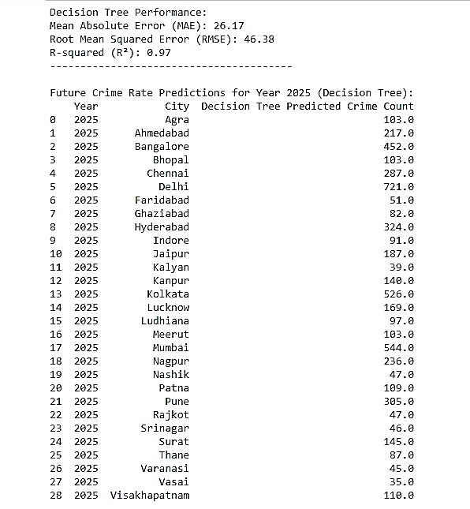

* **Final Model Selection: Decision Tree**

After evaluating all models, it was clear that the **Decision Tree model** provided more accurate and reliable predictions compared to the other models. The Decision Tree model effectively handled the non-linear nature of crime data and complex interactions between factors such as city population, crime type, and victim demographics. Therefore, the **Decision Tree model**, with its high accuracy of **97%**, was selected as the final model for predicting future crime rates.

# **Conclusion**

The "Crime Rate Prediction and Trend Analysis" project successfully utilized historical crime data from various Indian cities to predict future crime rates and trends. The project implemented several machines learning models, including K-Nearest Neighbors (KNN), Linear Regression, and Decision Tree, to predict crime occurrences and understand crime patterns. The Decision Tree model was chosen as the final model due to its high accuracy of 97%, outperforming the other models in handling the complex relationships present in the dataset.

By leveraging data visualization and predictive modeling techniques, the project provides valuable insights for law enforcement agencies. It highlights cities with the highest crime rates (e.g., Delhi and Mumbai) and identifies factors such as victim age, gender, crime type, and police resource allocation. These findings can assist authorities in optimizing resource management and developing targeted crime prevention strategies.

# **Future Direction**

The "Crime Rate Prediction and Trend Analysis" project has built a solid foundation for predictive crime analytics, but there is potential for further improvement. Future efforts could focus on incorporating more diverse data sources, such as socioeconomic factors and real-time data from social media, to refine the prediction models. Additionally, geospatial analysis, which maps crime occurrences to specific areas, and time-series forecasting could enhance predictive accuracy. Real-time model deployment, allowing law enforcement agencies to act on predictions proactively, and improving model interpretability using techniques like SHAP or LIME for better decision-making could also be valuable directions. Finally, deploying the model as a web or mobile app could give law enforcement real-time access to insights for crime prevention.

# **Bibliography**

1. **Breiman, L.** (2001). Random forests. Machine learning, 45(1), 5-32.
2. **Friedman, J. H.** (2001). Greedy function approximation: a gradient boosting machine. Annals of statistics, 1189-1232.
3. **James, G., Witten, D., Hastie, T., & Tibshirani, R.** (2013). An introduction to statistical learning (Vol. 112, p. 18). New York: Springer.
4. **Hastie, T., Tibshirani, R., & Friedman, J.** (2009). The elements of statistical learning: data mining, inference, and prediction (Vol. 2). New York: Springer.
5. **Chen, T., & Guestrin, C.** (2016). Xgboost: A scalable tree boosting system. In Proceedings of the 22nd acm sigkdd international conference on knowledge discovery and data mining (pp. 785-794)

# **10. References**

1. [Dr.N.Sreekanth, M.Akhila, N.Shivani, P.Nalini Priya: Crime Data Analsysis And Prediction Using Decision Tree: Malla Reddy Engineering College For Women Maisammaguda,Hyderabad, Ts, India, Turkish Journal Of Computer And Mathematics Education. Vol.14 No.02,590- 594 (2023)](https://turcomat.org/index.php/turkbilmat/article/download/13690/9834/24457)
2. [R. Karthik Sriraam, S.M. Keerthivasan, K. Sukant, A. Krishnamoorthy: Crime Prediction and Analysis: , Vellore Institute of Technology, Vellore, Tamil Nadu, India, Journal of Pharmaceutical Negative Results. Vol.13, No.02, (2022)](https://www.pnrjournal.com/index.php/home/article/download/378/246/531)
3. P.Nageswara Rao, T. Yaswanthsai, V. Sai Ram Nikhil, K. Siddu, S. Janaki[: Crime Data Analysis:Priyadarshini Institute Of Technology And Science, Chintalapudi,Guntur, Andhrapradesh, India, Zkg International. Vol.9, No.01, (2024)](https://zkginternational.com/archive/volume9/CRIME-DATA-ANALYSIS.pdf)
4. [Shradha Rajput, Minal Thombare, Sawan Kumar, Aachal Gupta, Dr. Radhika Nanda: Crime Analysis and Prediction Using Machine Learning: Indira Gandhi College of Engineering, Ghansoli, Navi Mumbai, Maharashtra, India, International Research Journal of Engineering and Technology (IRJET). Vol.11, No.04, (2024)](https://www.irjet.net/archives/V11/i4/IRJET-V11I4287.pdf)
5. **SudhanvaHG**. (2020). *Kaggle*. Retrieved from <https://www.kaggle.com/datasets/sudhanvahg/indian-crimes-dataset>
6. **Seaborn Documentation** (n.d.). Retrieved from <https://seaborn.pydata.org/>
7. **Scikit-learn Documentation** (n.d.). Retrieved from <https://scikit-learn.org/stable/>